

"Smart Embedded Helmet for Enhanced Accident Detection and Safety Lock Integration"

CAPSTONE PROJECT REPORT

MICROCONTROLLERS AND INTERFACING
19ECE304

CAPSTONE PROJECT REPORT SUBMITTED BY:
1. Siva Keerthi G K (CH.EN.U4ECE22043)
2. Thanu T (CH.EN.U4ECE22050)
3. Rohith Periya Karuppan K (CH.EN.U4ECE22056)

SUBMITTED TO :

Mrs. GAYATHRI M
Asst. Professor Dept. of E.C.E,
Amrita School of Engineering,
Chennai Campus

INTRODUCTION:
In recent years, motorcycle accidents have become a significant global concern, leading to severe injuries and fatalities among riders. Traditional helmets offer limited protection, focusing primarily on impact resistance without addressing the crucial need for immediate assistance during accidents. To tackle this issue, there is a growing demand for innovative solutions that not only enhance safety but also improve the overall riding experience. The Embedded Smart Helmet System aims to address these challenges by integrating advanced technologies to provide real-time accident detection and response capabilities.
The proposed system employs a combination of a gyroscope and GPS to accurately detect changes in motion and location during an accident. When an incident occurs, the system activates a GSM module that alerts emergency services and designated contacts with crucial accident details, ensuring timely medical assistance. This automatic notification feature is vital in emergencies, where every second counts, significantly increasing the chances of survival and minimizing the consequences of accidents.
Beyond the accident alert mechanism, the smart helmet incorporates a secure key lock system that ensures the rider can only start their motorcycle when wearing the helmet. An infrared (IR) sensor detects whether the helmet is being worn and communicates with a stepper motor to unlock the bike's key insertion locket. This functionality promotes responsible riding habits by ensuring the motorcycle cannot be started without adequate safety gear, while also enhancing convenience for the rider.
The Embedded Smart Helmet System is designed with two key functionalities: accident detection and alert, and a safety and key lock mechanism. The accident detection and alert functionality is powered by a sensor that continuously monitors the helmet’s motion and orientation, providing real-time data on angular velocity and linear acceleration. By setting threshold values for significant changes in motion, such as sudden stops or falls, the system can accurately identify potential accidents. Upon detecting such incidents, the system utilizes GPS technology to determine the rider's location and sends automated alerts via GSM, including essential information like the accident's location and time.
The safety and key lock mechanism is crucial for ensuring that the motorcycle can only be started when the helmet is worn. An IR sensor monitors for the helmet’s occupancy, and upon confirmation, it communicates the status to the system. This wireless communication between the helmet and the motorcycle ensures that the key lock system responds appropriately to the helmet's status. Once the helmet is confirmed to be worn, the system activates a stepper motor to unlock the key insertion locket, allowing the rider to safely start the vehicle. This design not only encourages responsible riding by preventing the operation of the motorcycle without safety gear but also enhances the overall user experience by providing clear feedback and smooth operation.
Overall, the innovative combination of these technologies fosters a safer riding environment and encourages adherence to safety protocols, ultimately reducing the risk and severity of accidents. The Embedded Smart Helmet System represents a significant advancement in motorcycle safety, providing riders with the reassurance that they are protected and connected throughout their journeys.
Keywords: GSM Module Communication, GPS Location Tracking, Infrared (IR) Sensor, Secure Key Lock Mechanism, Gyroscope and Accelerometer Integration

LITERATURE SURVEY:
1. IoT Based Smart Helmet and Accident Identification System
- Problem: Motorcycle accidents are a major cause of death, often due to head injuries. The problem addressed is improving the safety of motorcycle riders by ensuring they wear helmets and preventing them from driving under the influence of alcohol. Additionally, the system helps identify accidents and alerts emergency services to the accident's location.
- Microcontroller: Arduino
- Sensors: IR sensor Alcohol sensor,3-axis accelerometer, Load sensor
- Technology: The system employs IoT, Bluetooth communication, and RF communication. A mobile application connects to the helmet and motorcycle circuits for accident detection. It enables real-time location sharing with emergency contacts via GPS and GSM, ensuring prompt assistance in case of an accident.
- Comparison: This project ensures helmet use and detects accidents for road safety, while our project controls a locket mechanism using a stepper motor and nRF wireless communication. Both utilize sensors and wireless technology, but their focuses differ. The smart helmet targets accident prevention, whereas ours automates a physical mechanism (locket opening).
2.Design & Implementation of IoT-Based Smart Helmet for Road Accident Detection
- Problem:
Road accidents involving bikers are a significant issue, especially in countries with narrow roads and high populations. The project aims to improve biker safety through accident detection.
- Microcontroller: Arduino
- Sensors: Accelerometer, GPS, Pressure sensor
- Technology: The system utilizes an IoT-based approach to detect accidents and report the location to emergency services. This ensures timely assistance and enhances overall biker safety.
- Comparison: This project focuses on road safety and employs IoT to detect accidents in real-time, whereas your project deals with a wireless-controlled mechanism (locket) using nRF modules. Both projects involve wireless communication, but their application and scope are quite different.

3. An IoT Based Smart System for Accident Prevention and Detection
- Problem: The project addresses the increasing number of bike accidents caused by various factors, such as not wearing helmets, alcohol consumption, and drowsiness while driving. It aims to prevent accidents and detect them early to inform nearby hospitals and authorities.
- Sensors: Alcohol sensor, vibration sensor, accelerometer, eye blink monitoring, ultrasonic sensor, and RFID.
- Technology: The system employs IoT, Vehicle-to-Vehicle (V2V) communication, RFID for license validation, Mobile Edge Computing (MEC), and GSM modules for real-time notifications and accident reporting.
- Comparison: This project focuses on accident prevention and detection using a variety of sensors and IoT communication, whereas our project centers on wireless communication for controlling a locket mechanism using nRF modules. Both projects involve real-time detection and notification systems, but the context and applications differ significantly. While this system emphasizes public safety, your project deals with automation in a controlled environment.
4. Accidental Identification and Navigation System in Helmet
- Problem: Road accidents due to non-usage of helmets and lack of immediate help after accidents. The system promotes helmet usage and alerts emergency services in case of an accident.
- Sensors: Pressure sensors for accident detection.
- Technology: The system uses GSM for sending alerts, Bluetooth for voice calls, and a solar panel for external power. GPS is also employed for location tracking, with plans to integrate national navigation systems.
- Comparison: Both systems focus on accident detection and utilize GSM for alerts and GPS for tracking. However, your project includes a unique Safety and Key Lock Mechanism with IR sensors and stepper motors, enhancing safety by preventing the motorcycle from starting without a helmet.
5. Smart Helmet for Accident Detection and Notification
- Problem: Delays in accident reporting for two-wheelers lead to high fatalities. This system detects accidents and notifies emergency contacts.
- Microcontroller: Arduino
- Sensors: MPU6050 (Accelerometer and Gyroscope),NEO6M V2 GPS Module
- Technology: Uses GSM SIM900 for communication and IoT for cloud-based accident reporting.
- Comparison: Both utilize MPU6050 and GSM, but our project incorporates an IR sensor for helmet detection and nRF24L01 for wireless control, which this system does not have.
6. Smart and Assistive Driving Headgear
- Problem: Two-wheeler accidents frequently occur due to distractions, such as mobile phone use. The headgear enhances safety by ensuring helmet usage and minimizing distractions with a heads-up display (HUD).
- Microcontroller: Raspberry Pi 2
- Sensors: Pressure sensor (BMP180), Vibration sensor (SW420)
- Technology: Employs GSM, GPS, and HUD for navigation and call notifications, with RF communication between the helmet and the bike.
- Comparison: Both systems emphasize accident detection and helmet usage enforcement. our project integrates MPU6050 and nRF24L01 for wireless communication, while this headgear features a HUD for notifications and RF signals for synchronization with the bike.
7. Advanced Wireless Techniques to Avoid Accidents on Roads through Wearing Smart Helmet
- Problem: Addresses the high rate of motorcycle accidents due to non-compliance with helmet laws and alcohol consumption.
- Microcontroller: Arduino LilyPad for the bike unit,ARM7 LPC2148 for the helmet unit
- Sensors: MQ-135 Alcohol Sensor for alcohol detections Sensor for helmet usage confirmation, Accelerometer (MMA7361) for detecting rash driving and accidents
- Technology: Utilizes GSM for communication, GPS for location tracking, and RF for helmet-bike communication, ensuring the bike only starts with helmet usage and no alcohol detected.
- Comparison: Both systems use GSM and GPS for alerts and tracking. our project incorporates helmet detection and nRF24L01 communication, drawing from their RF integration and alcohol detection as potential enhancements.
8. Design of Smart Helmet for Accident Avoidance
- Problem: Addresses rising road accidents due to non-helmet use and alcohol consumption, ensuring motorcycles start only when the helmet is worn and the rider is sober, while also providing accident detection and emergency alerts with GPS coordinates.
- Microcontroller: Peripheral Interface Controller (PIC)
- Sensors: IR Sensor, Gas Sensor, Vibration Sensor, MEMS Sensor, Load Sensor
- Technology: Utilizes vibration sensors for accident detection, gas sensors for alcohol monitoring, GPS for location alerts, and ZigBee for wireless communication.
- Comparison: Both systems focus on accident detection and safety. Your project uses MPU6050 for motion sensing and ESP8266 for communication instead of ZigBee, along with nRF24L01 for helmet-bike communication and stepper motors for locking mechanisms. You also employ GSM SIM900 for real-time emergency alerts, enhancing overall safety.
9.Fall Detection of Riders using Inertial Sensors: A Smart Helmet
- Problem: This project addresses the critical issue of fatalities and severe injuries from falls during cycling or motorbike riding, which often go undetected. The goal is to create a helmet that detects falls and sends alerts via GSM with GPS coordinates for timely rescue.
- Microcontroller: Arduino and NodeMCU 12
- Sensors: MPU6050, Inertial sensors
- Technology: The helmet employs Bluetooth for wireless data transmission and utilizes machine learning algorithms like Naïve Bayes and KNN for fall detection, achieving up to 98.21% accuracy. A GSM module is included for sending alerts with GPS location data to rescue stations.
- Comparison: Both projects focus on fall detection and emergency alerts, but theirs relies on MPU6050 and Bluetooth, while yours incorporates ESP8266 and GSM SIM900 for robust communication. Your design also features safety mechanisms using nRF24L01 and IR sensors to ensure helmet usage, enhancing overall rider safety.
10.Smart Helmet with Motorbike Unit for Accident and Rash Driving Detection
- Problem: This project addresses reckless driving, drinking and driving, and the absence of helmets, focusing on accident detection and monitoring rider behaviour to ensure the motorbike only operates under safe conditions.
- Microcontroller: An Arduino Nano for the helmet unit and an Arduino Mega for the motorbike unit.
- Sensors: Pulse Rate Sensor, Accelerometer, MQ-3 Alcohol Sensor, LIDAR Sensor, Hall Effect Sensor, IR Sensors, Ultrasonic Sensors.
- Technology: The system employs the NRF24L01 module for wireless communication, GSM SIM900 and NEO-6M GPS modules for accident alerts, an OLED screen for notifications, and a buzzer for risky behaviour alerts.
- Comparison: This design aligns with our Embedded Smart Helmet System in accident detection and safety mechanisms but adds MPU6050 for motion tracking and a key lock mechanism for unauthorized bike use prevention, enhancing safety and promoting responsible riding behaviour.

11. Smart Helmet Prototype for Safety Riding and Alcohol Detection
- Problem: This project addresses the rising number of road accidents caused by helmet non-use, over-speeding, and riding under the influence of alcohol. It aims to enforce helmet usage and detect alcohol consumption, preventing the vehicle from starting if safety conditions are not met, while also alerting the rider's guardian in case of an accident.
- Microcontroller: Arduino Uno
- Sensors: Alcohol Sensor (MQ3), Accelerometer.
- Technology: The system employs a GSM module for accident alert notifications, RF communication between the helmet and bike for ignition control, and a GPS system for accident location tracking.
- Comparison: Both projects focus on enhancing rider safety through helmet enforcement and unsafe condition detection. However, while our project utilizes the MPU6050 sensor for accident detection and GPS NEO 6M for location tracking, the smart helmet prototype emphasizes alcohol detection and helmet usage verification before allowing the bike to start. Both integrate GSM technology for accident alerts but differ in sensor and microcontroller implementations.
COMPONENTS
- ESP 8266
- Arduino UNO
- IR SENSOR
- nRF24L01
- STEPPER MOTOR
- MPU 6050
- GSM SIM 900
- GPS NEO 6M
REQUIREMENTS
LIBRARIES:
- Wire.h
- Stepper.h
- RF24.h
- MPU6050.h
- SIM900.h
- Softwareserial.h

METHODOLOGY
The Embedded Smart Helmet System is designed with two key functionalities: Accident Detection and Alert, and Safety and Key Lock Mechanism. The Accident Detection and Alert functionality is powered by the MPU6050 sensor, which integrates a 3-axis gyroscope and a 3-axis accelerometer. This sensor continuously monitors the helmet’s motion and orientation, providing real-time data on angular velocity and linear acceleration. By utilizing the MPU6050.h library, the system processes this data to establish threshold values for significant changes in motion, such as sudden stops or falls. If these thresholds are exceeded, indicating a potential accident, the system is triggered to respond.
To enhance the effectiveness of the accident alert, the GPS NEO 6M module is employed to determine the rider's location at the time of the incident. This module captures GPS coordinates, which are vital for notifying emergency services and designated contacts. Upon detecting an accident, the GSM SIM 900 module activates to send alert messages that include the accident's location, time, and nature. The GSM communication is managed through the SIM900.h library, allowing for seamless integration of emergency messaging. The system uses the Softwareserial.h library to establish a serial connection with the GSM module, ensuring that messages are sent efficiently to emergency contacts and services like 108.
The second functionality, Safety and Key Lock Mechanism, is essential for ensuring that the motorcycle can only be started when the helmet is worn. This feature employs an IR Sensor that detects the presence of the rider's head. The IR sensor continuously monitors for the helmet's occupancy, and when it confirms that the helmet is being worn, it communicates this status to the system. To facilitate wireless communication between the helmet and the motorcycle, the nRF24L01 module is integrated, utilizing the RF24.h library for configuration and management. This wireless link ensures that the motorcycle's key lock system is responsive to the helmet's status.
Upon detecting that the helmet is worn, the system activates a Stepper Motor to unlock the bike's key insertion locket, allowing the rider to safely start the vehicle. The Stepper.h library controls the stepper motor, enabling precise mechanical movements for unlocking the key mechanism. This design not only promotes responsible riding by preventing motorcycle operation without adequate safety gear but also enhances user experience by providing clear feedback. Overall, this innovative combination of technologies fosters a safer riding environment and encourages adherence to safety protocols.
BLOCK DIAGRAM
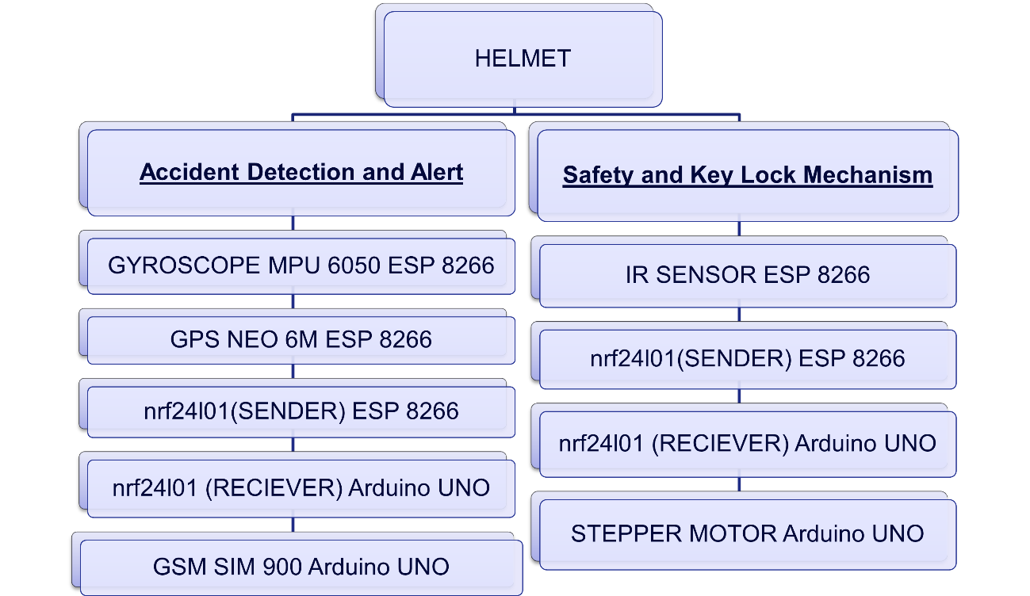

CODE:
ESP 8266

ARDUINO UNO
#include <SPI.h>
#include <nRF24L01.h>
#include <RF24.h>
#include <AccelStepper.h>
#include <TinyGPS++.h>
#include <SoftwareSerial.h>

// Define nRF24L01 pins
#define CE_PIN 9
#define CSN_PIN 10

// Create an RF24 object
RF24 radio(CE_PIN, CSN_PIN);

// Define the stepper motor pins
#define IN1 2
#define IN2 3
#define IN3 4
#define IN4 5

// Define the SIM800 pins
#define SIM800_RX 10
#define SIM800_TX 11

// Create software serial for SIM800
SoftwareSerial sim800(SIM800_RX, SIM800_TX);

// Create a SoftwareSerial object for the GPS module
SoftwareSerial gpsSerial(4, 3); // RX, TX pins for GPS

// Create a TinyGPS++ object
TinyGPSPlus gps;

// Define the stepper motor steps
const int stepsPerRevolution = 2048; // Adjust as necessary for your motor

// Create an AccelStepper object
AccelStepper stepper(AccelStepper::DRIVER, IN1, IN2);

// Flag to ensure the stepper rotates only once
bool hasRotated = false;

void setup() {
Serial.begin(9600); // Start serial communication for debugging
sim800.begin(9600);
delay(3000); // Wait for SIM800 to initialize

// Initialize GPS module
gpsSerial.begin(9600); // Start serial communication for GPS module

// Check if SIM800 is responding
sim800.println("AT");
delay(1000);
readSIM800Response();

// Initialize nRF24L01
radio.begin();
radio.openReadingPipe(1, 0xF0F0F0F0E1LL); // Address (should match with ESP8266)
radio.setPALevel(RF24_PA_HIGH);
radio.setDataRate(RF24_1MBPS);
radio.startListening(); // Set as receiver

// Initialize stepper motor
stepper.setMaxSpeed(1000); // Set max speed
stepper.setAcceleration(500); // Set acceleration
}

void loop() {
// Check for incoming messages from nRF24L01
if (radio.available()) {
char receivedMessage[32] = ""; // Buffer size
radio.read(&receivedMessage, sizeof(receivedMessage));

// Process received messages
if (strcmp(receivedMessage, "OBJECT_DETECTED") == 0) {
Serial.println("LOCK IS OPEN.");
if (!hasRotated) {
stepper.moveTo(stepsPerRevolution / 2); // Rotate 180 degrees
stepper.runToPosition(); // Block until the motor reaches the target position
hasRotated = true;
sendSMS("EMERGENCY ALERT: Object Detected and Lock is Open."); // Send SMS
sendGPSLocation(); // Send GPS location
}
} else if (strcmp(receivedMessage, "OBJECT_NOT_DETECTED") == 0) {
Serial.println("Object not detected.");
if (hasRotated) {
stepper.moveTo(0); // Return to initial position
stepper.runToPosition(); // Block until the motor returns
hasRotated = false;
}
}
}

// Check if there's data available from the GPS
while (gpsSerial.available() > 0) {
gps.encode(gpsSerial.read()); // Encode the GPS data

// If a new GPS fix is available
if (gps.location.isUpdated()) {
Serial.print("Latitude: ");
Serial.print(gps.location.lat(), 6); // Print latitude with 6 decimal places
Serial.print(", Longitude: ");
Serial.println(gps.location.lng(), 6); // Print longitude with 6 decimal places
}
}

// Update the stepper motor
stepper.run(); // This call should be in the loop to keep the stepper moving
}

// Function to send SMS
void sendSMS(const char* message) {
// Set the GSM module to text mode
sim800.println("AT+CMGF=1");
delay(1000);

// Send the phone number of the recipient (replace with your phone number)
sim800.println("AT+CMGS=\"+917530006713\""); // Replace with your phone number (with country code)
delay(1000);

// Type the message to send
sim800.println(message);
delay(1000);

// Send CTRL+Z (ASCII code 26) to indicate the end of the message
sim800.write(26);
delay(3000); // Allow time for message to be sent

// Print a confirmation to Serial Monitor
Serial.println("Message Sent!");

// Check for any response from SIM800
readSIM800Response();
}

// Function to read SIM800 responses
void readSIM800Response() {
while (sim800.available()) {
String response = sim800.readString();
Serial.println("GSM Module Response: " + response);
}
}

// Function to send GPS location (could be included in SMS)
void sendGPSLocation() {
// Example message to send GPS location
String locationMessage = "Current Location: ";
if (gps.location.isValid()) {
locationMessage += String(gps.location.lat(), 6) + ", " + String(gps.location.lng(), 6);
} else {
locationMessage += "Location not available.";
}
sendSMS(locationMessage.c_str()); // Send location via SMS
}
RESULTS:
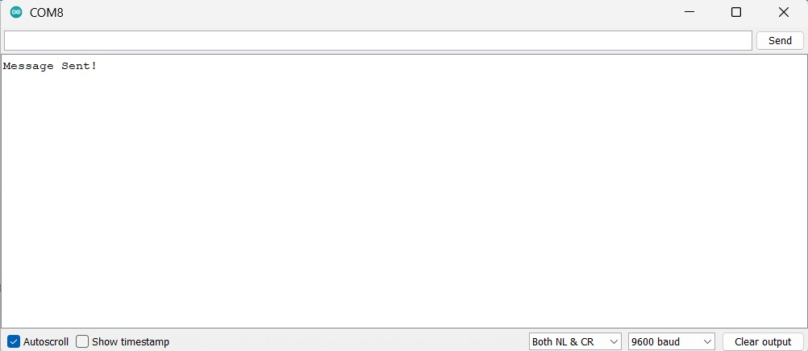

CONCLUSION:
The smart helmet project effectively enhances rider safety by integrating technologies like the MPU6050 for accident detection, GPS for location tracking, nRF24L01 for communication, and SIM800 GSM for emergency messaging. It ensures the helmet is worn before unlocking the bike and alerts emergency contacts with location details in case of an accident, showcasing the potential of embedded systems to improve road safety and emergency response in intelligent safety gear.
REFERENCES:
[1]M. A. Rahman, S. M. Ahsanuzzaman, I. Rahman, T. Ahmed and A. Ahsan, "IoT Based Smart Helmet and Accident Identification System," 2020 IEEE Region 10 Symposium (TENSYMP), Dhaka, Bangladesh, 2020, pp. 14-17
[2]M. E. Alim, S. Ahmad, M. N. Dorabati and I. Hassoun, "Design & Implementation of IoT Based Smart Helmet for Road Accident Detection," 2020 11th IEEE Annual Information Technology, Electronics and Mobile Communication Conference (IEMCON), Vancouver, BC, Canada, 2020, pp. 0576-0581
[3]S. Nanda, H. Joshi and S. Khairnar, "An IOT Based Smart System for Accident Prevention and Detection," 2018 Fourth International Conference on Computing Communication Control and Automation (ICCUBEA), Pune, India, 2018, pp. 1-6
[4]A. Ajay, G. Vishnu, V. Kishoreswaminathan, V. Vishwanth, K. Srinivasan and S. Jeevanantham, "Accidental identification and navigation system in helmet," 2017 International Conference on Nextgen Electronic Technologies: Silicon to Software (ICNETS2), Chennai, India, 2017, pp. 202-204
[5]S. A. Shabbeer and M. Meleet, "Smart Helmet for Accident Detection and Notification," 2017 2nd International Conference on Computational Systems and Information Technology for Sustainable Solution (CSITSS), Bengaluru, India, 2017, pp. 1-5
[6]S. Karthikeyan, S. Singh, H. M. Jain, M. Sailesh Kumar and V. Priya, "Smart and Assistive Driving Headgear," 2018 3rd International Conference on Communication and Electronics Systems (ICCES), Coimbatore, India, 2018, pp. 335-339
[7]M. M S, A. R, S. T, S. M S and C. A. S, "Advanced Wireless techniques to avoid accidents on roads through wearing Smart helmet," 2021 5th International Conference on Intelligent Computing and Control Systems (ICICCS), Madurai, India, 2021, pp. 258-264
[8]A. Jesudoss, R. Vybhavi and B. Anusha, "Design of Smart Helmet for Accident Avoidance," 2019 International Conference on Communication and Signal Processing (ICCSP), Chennai, India, 2019, pp. 0774-0778
[9]A. Iqbal, A. Iqbal, H. Ali, M. Ehatisham-ul-Haq, A. Arsalan and A. Raheel, "Fall Detection of Riders using Inertial Sensors: A Smart Helmet," 2021 International Bhurban Conference on Applied Sciences and Technologies (IBCAST), Islamabad, Pakistan, 2021, pp. 620-624
[10]P. Pathak, "Smart Helmet with Motorbike unit for Accident and Rash Driving Detection," 2020 IEEE International Conference on Advances and Developments in Electrical and Electronics Engineering (ICADEE), Coimbatore, India, 2020, pp. 1-6
[11]R. K. Sharma, G. Kumar and B. J. S, "Smart Helmet Prototype For Safety Riding And Alcohol Detection," 2020 IEEE Bangalore Humanitarian Technology Conference (B-HTC), Vijiyapur, India, 2020, pp. 1-5

